

American International University-Bangladesh (AIUB)  
**Department of Computer Science  
Faculty of Science &Technology (FST)  
Fall 22_23**

**Section: D  
Group No: 7**

**PROJECT TITLE**

**Accident Detection and Alert Android System.**

A software Engineering project submitted

By

|  |  |  |  |  |
| --- | --- | --- | --- | --- |
| S/N | Student Name | Student ID | Contribution (%) | Individual Marks |
| 06 | Kazi Maruf Ahmad Alif | 19-40044-1 | 20% |  |
| 12 | Dihan, Anamul Hossain | 19-41414-3 | 20% |  |
| 14 | Sayed, Adnan | 19-41487-3 | 20% |  |
| 34 | Das., Mrinmoy | 20-43856-2 | 20% |  |
| 35 | Sakibul Akash | 20-43861-2 | 20% |  |

The project will be Evaluated for the following Course Outcomes

|  |  |  |
| --- | --- | --- |
| Your Project will be Evaluated based on the following marking criteria | | Total Marks |
|  |
| Identify and Analyze Requirements (functional, quality, and project req.) | [5Marks] |  |
| Design the System Interface (UI/UX design) | [5Marks] |  |
| Prepare Test cases and Test plan | [5Marks] |  |
| Prepare WBS and Project Schedule | [5Marks] |  |
| Identify potential risks and Prepare a risk management plan | [5Marks] |  |
| Submission, Completeness, Spelling, Grammar and Organization | [5Marks] |  |

Submission Date: 12/12/2022

# PRODUCT AND PROJECT DESCRIPTION

## System Features

* List down the system functional requirements that describes the system’s functionalities

## System Quality Attributes

* List down the quality attributes that describes how well the system should perform.

## Project Requirements

* List down the project constraints (e.g., time, budget, resources, environment, etc.) that should be followed in the project management.

# SYSTEM DESIGN SPECIFICATION

## UI/UX Design

* Design a prototype of your proposed solution (Web/Desktop/Mobile/Device) using the selected tools based on the UI/UX design principles.

# SYSTEM TEST PLAN

* Select a particular system (Web/Desktop/Mobile/Device) and identify various modules of the system so that they can be tested stand alone.
* Prepare test cases of testing the selected elements of your identified software (System functionalities AND System Quality Attributes)

# PROJECT MANAGEMENT PLAN

## Project Scheduling

* Identify all the micro tasks related to project management and categorize them within the WBS structure.
* Perform detailed effort estimation correspond with the WBS and schedule
* Draw a Gantt chart of the identified tasks from WBS based on the precedence of each task you’ve identified.

## Risk Analysis

* + Describe the available resources and their allocation in performing the project tasks
  + Identify all the potential risks in your project development and provide a mitigation plan

**Text Format:**

* Font Style: Times New Roman
* Font Size: 11
* Line space: 1
* Alignment: Justify
* Report Length: Maximum 10 pages (including cover page)

# 1. PRODUCT AND PROJECT DESCRIPTION

## 1.1 System Features:

## Functional Requirements:

1. At First User should install the App and click the sign-up button.

2. After click, User can see the Register Page. Here User should provide Name, Father’s Name, Mother’s Name, Date of Birth, E-mail Address, Vehicle Number, NID Number, trusted 5 Contact Number.

3. After Clicking the sign-up button, the random verification code will be generated and send to the users E-mail address. By working this process User can successfully complete the registration.

4. The user should register with their proper information that will save to the system database.

5. The Software shall allow user to login with their given username and password.

6. If the login successful, the homepage of the user account will be displayed.

7. If the username or password has been inserted wrong, the random verification code will be generated and send to the users E-mail address by the system retry login.

8. If the number of login attempt exceed its limit (4 times), the system shall block the user account login for 30 minutes.

9. Every Vehicle must have a Device. When an accident occurs, the device will trigger an alarm.

10. The device will be equipped with collision sensors, A collision sensor is a piece of electronic safety equipment that detects an impact through vibrations. Collision sensors are also known as impact sensors. Collision sensors are used in many industrial settings, including manufacturing and utilities. These sensors will trigger the alarm in the device and the device will take the following actions immediately.

11. It works when the vehicle:

a. Sudden Stop.

b. Increased pressure as pieces of the vehicle is moved due to the force collision.

c. Fire detected

12. The System receive the Notification with location. The Notification will show the Notification box of the system.

13. The System will call the user.

14. If the User response it, the System will ask how the system can help.

15. The User told the system what he needs.

16. If the user can’t response, the system automatically provided the necessity thing within 10 minutes to the accident spot.

## 1.2 System Quality Attributes:

## Performance:

## 1. Every page shall be load within 3 seconds.

2. Registration process should not take more than 15 seconds.

3. Sign Up authorization should not take more than 10 seconds.

4. Random Verification code should not take more than 1 second to be generated.

5. It should not take more than 60 seconds to send verification code to user’s email.

6. The device should trigger the alarm between 10-20 miliseconds after accident/collision detected.

7. The system should call the user within 90seconds after any accident/collision detected.

Efficiency: At least 25 percent of the processor capacity and RAM available to the application shall be un used at the planned peak load conditions

Flexibility: A maintenance programmer who has at least one year of experience supporting this product shall be able to make a new copy output available to the product, including code modifications and testing, with no more than two hour of labor

Maintainability: A maintenance programmer shall be able to fix an error within 24 labor hours or less of development effort.

Integrity: Only user will know their password, passwords should be saved in hash format in database.

## 1.3Project Requirements

**Time:** We want to complete our project within 14 weeks.

**Budget:** Our budget is 5 Lacs to complete this project.

**Resources:** 20 skilled multitasking developers**,** Jira, Google chrome, Azure DevOps Server, Netbeans, proper monitor setup, GPU, CPU, RAM

## 2. SYSTEM DESIGN SPECIFICATION

## UI/UX Design:

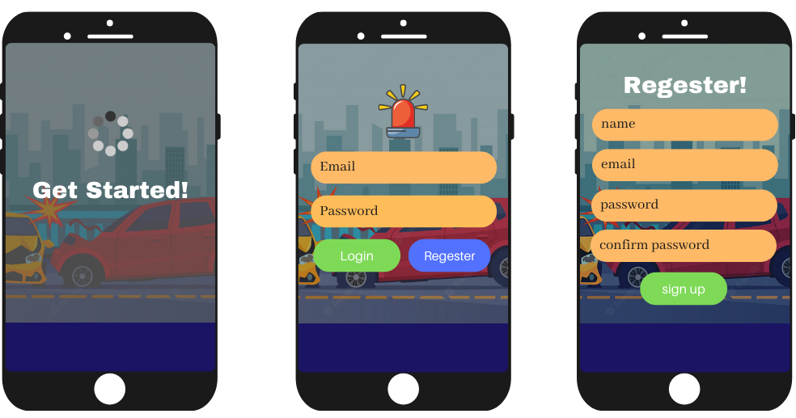

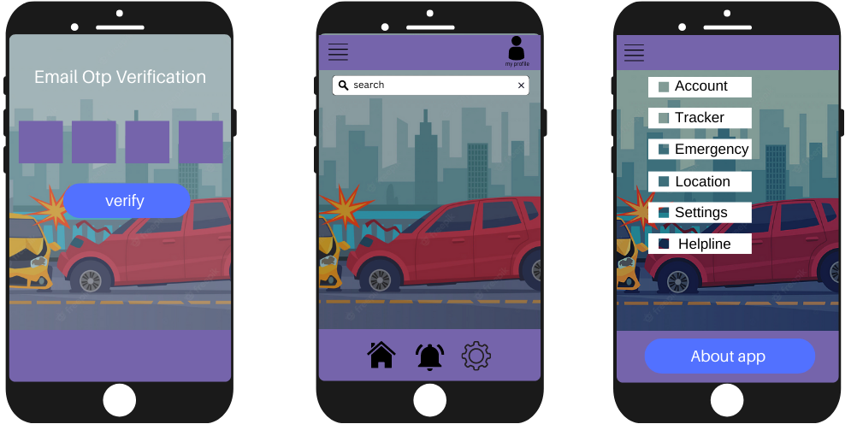

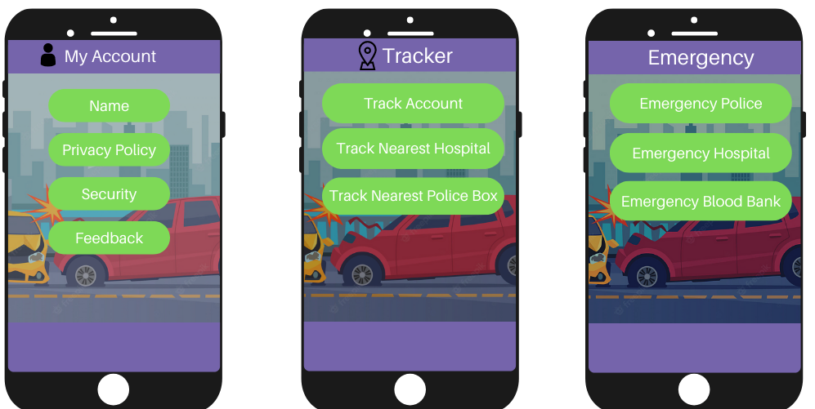

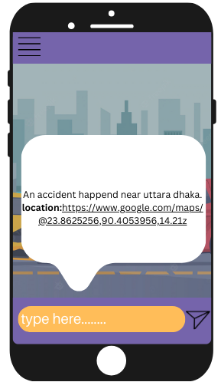

# 3. SYSTEM TEST PLAN:

Our developed software will be operated in Mobile.

Here are the list of modules of system that can be tested stand alone,

1. User Registration 2.Login Session. 3. Accident Detection Device. 4. Software System

Module testing techniques used:

1. User Registration: Integration testing, black box testing.

2. Login Session: Integration testing, unit testing, security testing, Black box testing.

3. Accident Detection Device: Integration testing, Unit testing, White Box testing.

4. Software System: Integration testing, Unit Testing, White Box Testing.

|  |  |  |  |  |  |
| --- | --- | --- | --- | --- | --- |
| Project Name: Accident Detection and Alert Android System | | | Test Designed by: Adnan | | |
| Test Case ID: FR_1 | | | Test Designed date: 22/11/22 | | |
| Test Priority (Low, Medium, High): High | | | Test Executed by: Dihan | | |
| Module Name: User Registration | | | Test Execution date: 20/12/22 | | |
| Test Title: User should register the app | | | | | |
| Description: User should install the app and giving correct information | | | | | |
| Precondition (If any): User must give proper information. | | | | | |
| Test Steps | Test Data | Expected Results | | Actual Results | Status (Pass/Fail) |
| 1. Install the app.  2. Click sign-up button  3. Go to the information providing page  4. Verification code will be provided  5.Click submit | Email: adnansayed@gmail.com  Vehicle Number: 1243572  NID Number: 127393803847 | User should able the access the application without any issue. | | As expected, | Pass |
| Post Condition: User should register to his/her account and fill the information’s carefully. | | | | | |

Table **01**:***Test Case for user* registration*.***

|  |  |  |  |  |  |
| --- | --- | --- | --- | --- | --- |
| Project Name: Accident Detection and Alert Android System | | | Test Designed by: Mrinmoy | | |
| Test Case ID: FR_2 | | | Test Designed date: 22/11/22 | | |
| Test Priority (Low, Medium, High): High | | | Test Executed by: Akash | | |
| Module Name: Login Session | | | Test Execution date: 29/12/22 | | |
| Test Title: verify login with valid username and password | | | | | |
| Description: Test Mobile login page | | | | | |
| Precondition (If any): User must have valid username and password | | | | | |
| Test Steps | Test Data | Expected Results | | Actual Results | Status (Pass/Fail) |
| 1. Go to the Mobile App 2. Enter username 3. Enter password 4. Click submit | Username: 99999999999  Password: 321 | User should login into the application | | As expected, | Pass |
| Post Condition: User is validated with database and successfully login to account. The account session details are logged in the database. | | | | | |

**Table 02**: Test Case for user Login

|  |  |  |  |  |  |
| --- | --- | --- | --- | --- | --- |
| Project Name: Accident Detection and Alert Android System | | | Test Designed by: Alif | | |
| Test Case ID: FR_3 | | | Test Designed date: 24/11/22 | | |
| Test Priority (Low, Medium, High): High | | | Test Executed by: Adnan | | |
| Module Name: Accident Detection Device | | | Test Execution date: 15/01/23 | | |
| Test Title: Detected accident | | | | | |
| Description: Test device to detect accident | | | | | |
| Precondition (If any): User must have valid a device and a sensor | | | | | |
| Test Steps | Test Data | Expected Results | | Actual Results | Status (Pass/Fail) |
| 1. The device triggers an alarm. 2. Collision sensor detects an impact through vibration 3. The device will send notifications. | Accident detection and notification location: Dhaka Kuratoli | User can notify the system accident with location | | As expected, | Pass |
| Post Condition: The system will notify accident location through the device. | | | | | |

**Table 03:** Test Case for detect accident

|  |  |  |  |  |  |
| --- | --- | --- | --- | --- | --- |
| Project Name: Accident detection and Alert Android System | | | Test Designed by: Mrinmoy | | |
| Test Case ID: FR_4 | | | Test Designed date: 16/12/22 | | |
| Test Priority (Low, Medium, High): High | | | Test Executed by: Dihan | | |
| Module Name: Software system | | | Test Execution date: 29/01/22 | | |
| Test Title: Sensor will give notification | | | | | |
| Description: Test with sensor device | | | | | |
| Precondition (If any): User must have a sensor device. | | | | | |
| Test Steps | Test Data | Expected Results | | Actual Results | Status (Pass/Fail) |
| 1. The system will receive the notification with location. 2. Calling the user 3. System will ask how the system will help 4. If user can’t response, then it will work automatically. | Notification and location:  Badda, Uttara | User expected necessity items within 10min | | As expected, | Pass |
| Post Condition: None | | | | | |

**Table 04:** Test Case for sensor device

# 4. PROJECT MANAGEMENT PLAN:

## 4.1Project Scheduling:

Effort estimation:

PM : person-months needed for project (labor working hours)

SLOC : source lines of code =90K(semidetached)

P : project complexity = 1.12 (semidetached)

DM : duration time in months for project (weekdays)

T: SLOC-dependent coefficient =0.35(semidetached)

ST : average staffing necessary.

Effort = PM = Coefficient*(SLOC/1000) ^ P=3*(90000/1000) ^ 1.12=463.31hours.

Development time = DM = 2.50*(PM) ^ T =2.50*(463.31) ^ 0.35=21.43weekdays.

Required number of people = ST = PM/DM=463.31/21.43=21.61≈22

* **Gantt Chart :**

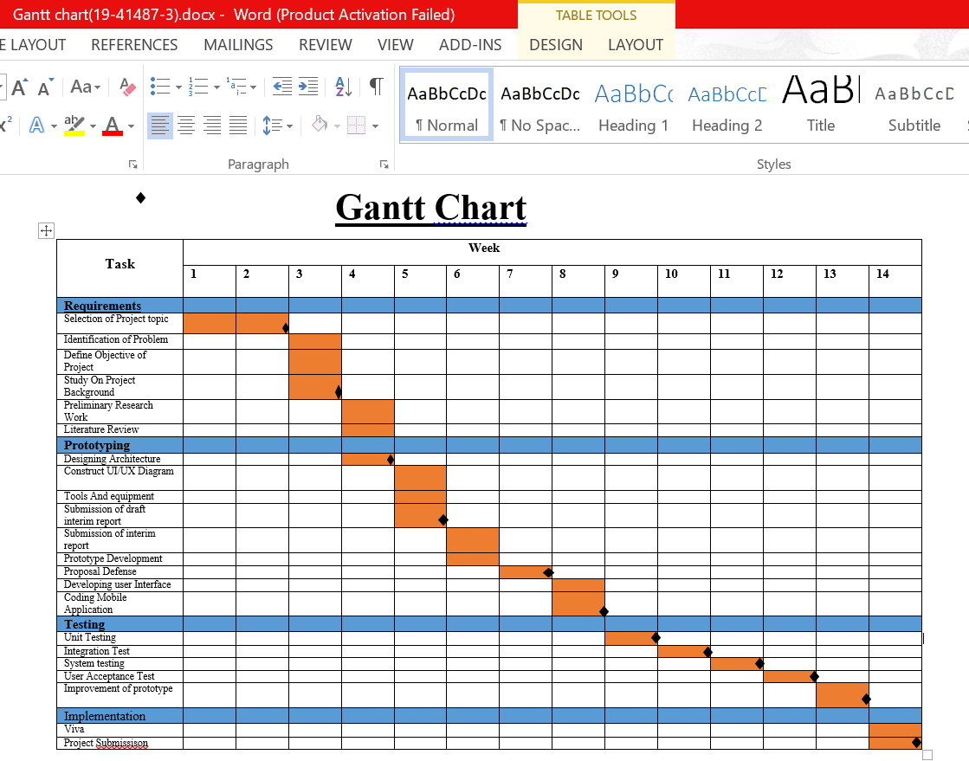

**Risk Analysis:**

Resource allocation

Human Resources: 20 skilled developers working in same office

Reusable Software Resources: Registration session, Login session

Environmental Resources: Jira, Google chrome, Azure DevOps Server, Netbeans

|  |  |  |  |
| --- | --- | --- | --- |
| **Risk** | **Category** | **Probability** | **Impact** |
| Size estimate may be significantly low | PS | 50% | 3 |
| Larger number of users than planned | PS | 30% | 3 |
| Fail to identify the victim | TE | 60% | 2 |
| Loss of GPS Tracking | TE | 40% | 1 |
| Funding will be lost | CU | 40% | 1 |
| Technology will not meet expectations | TE | 30% | 2 |
| Lack of training on tools | DE | 60% | 3 |
| Staff inexperienced | ST | 70% | 2 |
| Server Failure | TE | 60% | 2 |